
REPUBLIC OF KENYA

MINISTRY OF LABOUR AND SOCIAL PROTECTION

State Department for Labour and Skills
Development

JULY-SEPTEMBER 2024 LABOUR MARKET INDICATORS
REPORT ON EMPLOYABILITY SKILLS IN AGRICULTURE, MANUFACTURING AND CONSTRUCTION SECTORS

DIRECTORATE OF LABOUR MARKET RESEARCH AND ANALYSIS
OCTOBER, 2024
Table of content
Preface ................................................................................................................................................... 2
INTRODUCTION ..................................................................................................................................... 3
Scope of the Report .............................................................................................................................. 3
Methodology ......................................................................................................................................... 3
Data Collection ...................................................................................................................................... 3
Data Cleaning and Analysis Process ..................................................................................................... 3
Limitations ............................................................................................................................................. 4
FINDINGS ............................................................................................................................................... 5
AGRICULTURE SECTOR ........................................................................................................................ 5
MANUFACTURING SECTOR ................................................................................................................. 6
CONSTRUCTION SECTOR .................................................................................................................... 8
CONCLUSION ......................................................................................................................................... 9

Figure 1: most sought skills in agriculture sector in July to September 2024 5
Figure 2: most sought skills in manufacturing sector in July to September 2024 7
Figure 3: most sought skills in construction sector in July to September 2024 8

Preface

In line with Kenya's Vision 2030 and the Bottom-Up Economic Transformation Agenda, the Directorate of Labour Market Research and Analysis has developed this Quarterly Indicators Report on Employability Skills within the Agriculture, Manufacturing, and Construction sectors. The goal of this report is to identify and analyze trends in employability skills demand, providing a resource to support workforce planning and policy development. By including the Construction sector, this report broadens its scope, acknowledging the growing significance of construction in Kenya's economic development and job creation strategy.
Kenya’s development frameworks, including the Vision 2030 and Medium-Term Plans, emphasize job creation and economic resilience. The Bottom-Up Economic Transformation Agenda further supports this vision, focusing on inclusive growth by targeting key sectors, such as agriculture, manufacturing, and construction. The Directorate plays a pivotal role by equipping policymakers and stakeholders with timely labor market insights and skill demand trends essential for driving a skilled workforce and aligning educational and training programs with sector needs.
This report is a continuation of our commitment to tracking labor demand, consolidating data from web-crawled job listings. It provides quantitative and qualitative insights into the employability skills most in demand across agriculture, manufacturing, and the newly incorporated construction sector. Through this information, we aim to support Kenya's economic agenda, fostering a competitive, adaptable, and well-prepared workforce for these key industries

SHADRACK M. MWADIME, CBS
PRINCIPAL SECRETARY, STATE DEPARTMENT FOR LABOUR AND SKILLS DEVELOPMENT

- INTRODUCTION
As Kenya's labor market landscape evolves, particularly within the agriculture, manufacturing, and construction sectors, understanding the demand for specific employability skills is increasingly important. This report presents the quarterly analysis of labor demand across these sectors, based on web-crawled data from job listings on various platforms. The inclusion of the construction sector reflects its growing role as a significant employer and its impact on the economy through infrastructure development and related projects.
The report examines labor demand trends, focusing on the key skills required by employers across agriculture, manufacturing, and construction. Agriculture remains a vital contributor to Kenya's GDP and employment levels, while manufacturing drives industrial growth and economic diversification. Construction, a rapidly growing sector, is central to Kenya's infrastructure agenda, playing a crucial role in supporting both economic and job creation goals.
By analyzing labor demand and skill trends within these three sectors, this report aims to inform stakeholders—including policymakers, training institutions, and job seekers—of the evolving workforce needs. This information provides guidance on areas where skill gaps exist, informing interventions to enhance employability and improve Kenya's labor market resilience.
- Scope of the Report
This quarterly report offers insights into employability skills demand within Kenya's Agriculture, Manufacturing, and Construction sectors. Data has been gathered through web-crawling techniques, ensuring comprehensive coverage of job listings across various platforms.
- Methodology
The methodology employed involves systematic data collection, cleaning, and analysis of job advertisement data. Key stages include:
Data Collection
Job postings were gathered using web crawlers that extracted data from multiple job websites within Kenya. The collected data includes job title, required skills, and sector classifications, providing a robust dataset for analysis.
Data Cleaning and Analysis Process
To ensure accuracy, raw data was cleaned and standardized, with occupations coded per the
Kenya Standard Classification of Occupations (KeSCO) and industries standardized using the Kenya Standard Industrial Classification of All Economic Activities (KeSIC). The cleaned data was then analyzed to identify the most frequently demanded skills, using both descriptive statistics and graphical presentations.

4. Limitations
This report acknowledges certain limitations, including:
- Data Source Reliability
The accuracy of findings is dependent on the completeness and accuracy of job listings from web sources, which may not capture all labor demand specifics.
- Sector Representation
While agriculture, manufacturing, and construction are covered, certain subsectors within these may be underrepresented due to limitations in job listing data availability.
- Skill Proxies
Using occupations as proxies for skills may not fully capture the complexity of skill requirements, as job postings often generalize skill descriptions.

- FINDINGS
5.1 AGRICULTURE SECTOR
The agriculture sector is the backbone of Kenya's economy, contributing significantly to employment, income generation, and food security. It accounts for a large portion of the country's GDP and employs the majority of the rural population. As Kenya moves towards modernization and industrialization in agriculture, there is a growing demand for new skills in areas like agribusiness, technology integration, and sustainable farming practices. Understanding the specific skill requirements in this sector is critical for enhancing productivity, promoting value addition, and ensuring that the sector remains competitive both locally and internationally.

MOST SOUGHT SKILLS IN AGRICULTURE SECTOR IN JULY TO SEPTEMBER 2024
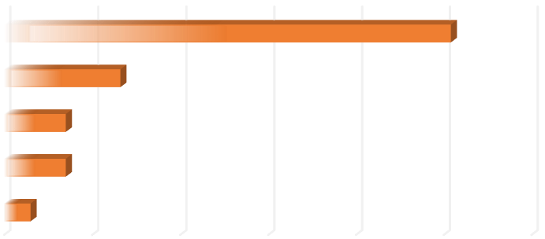

0
50
100
150
200
250
300
Engineering and IT skills
sales and Marketing
Numerical and financial skills
Business and management skills
core agricultural skills
NO. OF VACANCIES
SKILL
MOST SOUGHT SKILLS IN AGRICULTURE
SECTOR (JULY
-
SEPT 2024)

Figure 1: most sought skills in agriculture sector in July to September 2024

There is a significant demand for core agricultural skills, with 254 vacancies highlighting the need for technical expertise in areas like farming and crop management. Business and management skills (66 vacancies) are also sought after, reflecting the importance of agribusiness and leadership in driving sector growth. Sales and marketing (35 vacancies) and numerical/financial skills (35 vacancies) are critical for connecting agricultural products to markets and ensuring sound financial practices. Additionally, engineering and IT skills (15 vacancies) signal a shift towards innovation and technology adoption in agriculture. This trend suggests that the sector is evolving towards a more professionalized, market-oriented, and technology-driven approach, requiring stakeholders to focus on skill development and technological advancements to meet these emerging demands.

Implications for Job Seekers: The demand for core agricultural skills highlights the importance of technical knowledge in crop production and farm management. Job seekers should focus on gaining specialized training in these areas to enhance their employability in the sector. Additionally, developing business, marketing, and financial skills can provide a competitive advantage, as these roles are crucial for the commercialization of agricultural products. Familiarity with engineering and IT applications in agriculture can open up opportunities in innovative, tech-driven roles, further broadening career prospects.
Implications for Education/Training Institutions: The demand for diverse skill sets in agriculture, from core agricultural techniques to business, marketing, and technology, underscores the need for comprehensive and multidisciplinary training programs. Educational institutions should consider developing curricula that integrate agricultural sciences with business, finance, and IT skills to equip graduates with a holistic understanding of the sector. Emphasizing practical and hands-on training will also be essential to bridge the skills gap and meet the industry’s evolving needs.
Implications for Policy Makers: The data reveals a trend towards a more professionalized and technology-driven agricultural sector, indicating that policies must support skill development in both traditional agricultural practices and modern business and technology competencies. Policy makers should focus on creating enabling environments for skill-building programs and fostering partnerships between training institutions and the private sector. Supporting innovation and technological advancements in agriculture will be key to boosting productivity and aligning workforce capabilities with market demands.
5.2 MANUFACTURING SECTOR
Manufacturing is a key driver of Kenya's economic transformation and a central pillar in its Vision 2030 strategy, which aims to make the country a newly industrialized middle-income economy. The sector plays a vital role in adding value to raw materials, creating jobs, and stimulating economic growth. As the country aims to expand its industrial base, there is an increasing need for a skilled workforce that can adapt to technological advancements and global market demands. Addressing this is essential for Kenya to realize its full industrial potential and boost its position in the regional and global markets.

MOST SOUGHT SKILLS IN MANUFACTURING SECTOR IN JULY TO SEPTEMBER 2024
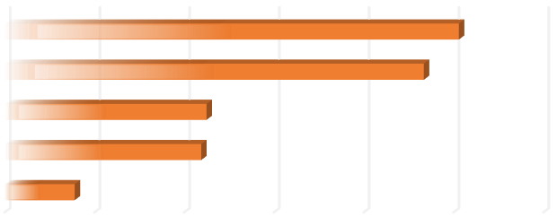

0
100
200
300
400
500
600
administrative and clerical skills
Sales and Marketing skills
Numerical and Financial skills
Leadership and management skills
Engineering and IT skills
NO. OF VACANCIES
SKILL
MOST SOUGHT SKILLS IN
MANUFACTURING SECTOR (JULY
-
SEPT
2024)

Figure 2: most sought skills in manufacturing sector in July to September 2024

The most in-demand skills in the manufacturing sector for the first quarter, are engineering and IT skills, with a significant 506 vacancies advertised. Leadership and management skills follow closely with 467 vacancies, highlighting the need for capable leaders to drive manufacturing processes and innovations. Numerical and financial skills also show strong demand at 225 vacancies, essential for managing budgets, costs, and efficiency. Sales and marketing skills (219 vacancies) indicate the importance of reaching new markets and promoting manufacturing products, while administrative and clerical skills (78 vacancies) are needed to support operational and logistical tasks.
Implication for Job Seekers: The demand for engineering and IT skills within the manufacturing sector suggests that job seekers with technical expertise in these areas have a competitive advantage. Focusing on acquiring or upgrading skills in management and leadership could also be beneficial, given the high demand. Furthermore, individuals with a background in sales and marketing or numerical and financial skills should target roles that emphasize product promotion, customer engagement, and financial analysis.
Implication for Education and Training Institutions: Education and training institutions should tailor their programs to emphasize technical skills in engineering and IT, as these are the most sought-after in the manufacturing sector. They should also offer specialized courses in leadership and management to prepare future industry leaders. Collaborating with the industry to develop curricula that incorporate practical, real-world applications for sales, marketing, and financial skills will further enhance graduates' employability.
Implication for Policy Makers: Policy makers should focus on creating initiatives that support STEM education, particularly in engineering and IT, to meet the growing demand in the manufacturing sector. Strategies to enhance training in sales, marketing, and financial management will support the development of a well-rounded workforce for the manufacturing industry.
5.3 CONSTRUCTION SECTOR
The construction sector in Kenya is one of the fastest-growing industries, driven by urbanization, infrastructural development, and investment in public and private projects. It is one of the major contributors to Kenya's GDP and plays a crucial role in job creation and economic development. With the government's focus on implementing large-scale projects such as roads and affordable housing, the demand for skilled professionals in engineering, project management, and specialized trades continues to rise. As the sector evolves with new technologies and sustainable construction practices, it is vital to understand the skills required to ensure that Kenya's infrastructure development keeps pace with its ambitious growth plans.

MOST SOUGHT SKILLS IN CONSTRUCTION SECTOR IN JULY TO SEPTEMBER 2024
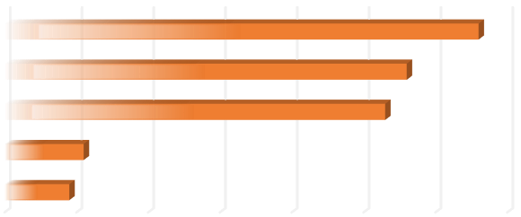

0
10
20
30
40
50
60
70
client relations and information skills
Numerical and financial skills
Engineering and IT skills
sales and marketing skills
leadership and Managerial skills
NO OF VACANCIES
SKILL
MOST SOUGHT SKILLS IN
CONSTRUCTION SECTOR (JULY
-
SEPT
2024)

Figure 3: most sought skills in construction sector in July to September 2024

Leadership and managerial skills are the most sought-after in construction sector, with 66 vacancies, emphasizing the need for effective leaders to guide projects and manage teams. Sales and marketing skills are also in high demand, with 56 vacancies, reflecting the importance of promoting construction services and acquiring new clients. Engineering and IT skills have 53 vacancies, highlighting the crucial role of technical expertise in construction projects. Numerical and financial skills (11 vacancies) and client relations and information skills (9 vacancies) are also needed to manage project finances and maintain client communications
Implication for Job Seekers: Job seekers should prioritize developing leadership and managerial skills if they wish to enter the construction sector, as these skills are in the highest demand. Additionally, a focus on enhancing sales and marketing capabilities can improve opportunities, as these roles are essential for project acquisition and customer engagement. Those with engineering and IT backgrounds should continue to refine their technical expertise to meet the needs of the industry.
Implication for Education and Training Institutions: Training institutions should focus on equipping students with strong leadership and managerial skills. Emphasizing sales and marketing as well as technical courses in engineering and IT will also align with the current demands of the sector. Incorporating financial management and client communication training into their curricula can further prepare graduates for the diverse roles in construction.
Implication for Policy Makers: Policy makers should consider initiatives that foster leadership development. Supporting STEM programs, particularly in engineering and IT, will also help fill the technical skill gaps in the industry.
- CONCLUSION
- Across these sectors, key skills such as engineering and IT, leadership and managerial, sales and marketing, and numerical and financial skills are repeatedly sought after. This indicates a strong need for professionals who can contribute to technical innovation, strategic business growth, and effective financial management.

- Understanding these trends is crucial for job seekers, educational institutions, and policymakers, as it helps guide workforce development initiatives and training programs. By focusing on these high-demand skills, Kenya can ensure that its labor force remains competitive and well-prepared for future industry needs.

- RECOMMENDATIONS
- Given the high demand for engineering and IT skills across all three sectors (agriculture, manufacturing, and construction), there is a need to increase investment in STEM (Science, Technology, Engineering, and Mathematics) education and vocational training.

- To ensure workforce development initiatives remain relevant and responsive to emerging labour market trends, the Ministry of Labour and Social Protection, in collaboration with key stakeholders, should institutionalize a skills forecasting and alignment framework.

